Big sound sensor

Overview：
This project is to test Sound Sensor module. The sensor A0 pin will output analog sound value. the D0 pin will output HIGH voltage (1) if value over the threshold, otherwise export LOW (0). the threshold can be adjust by screwdriver.

Materials：
Arduino Uno x 1
Big sound sensor x 1
DuPont wires x 4

Product description :
The Big Sound Sensor packages a sound-sensitive, capacitive electret microphone inside a convenience circuit that reports two outputs. As acoustic waves vibrate the thin electret film, they generate a small voltage, allowing the intensity of the sound to be reported as an analog output. At the same time, a digital output indicates whether that measured volume exceeds a particular user-adjustable threshold. Simple sound detection has many applications in automation, security, and novelty and entertainment technologies. In this experiment, you’ll use your Raspberry Pi and the analog-to-digital converter to monitor both outputs of the sound sensor.
The Big Sound Sensor is very similar to the Small Sound Sensor, except it contains a larger microphone, which makes it more sensitive to a broader range of sounds and therefore able to detect quieter noises. The wiring diagrams, experimental procedures and source code of both sound sensor experiments are the same.

Wiring diagram:
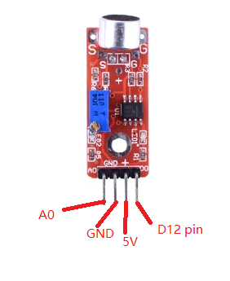

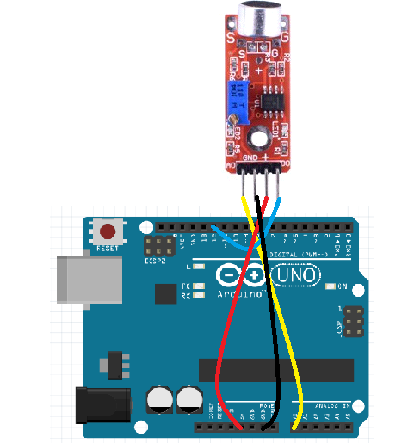

Example code:
/* sound sensor test project

int analog_sensor = A0; // select the input pin for the potentiometer
int digit_sensor = 12; // select the input pin for the potentiometer
int ledPin = 3; // select the pin for the LED
int analogValue ; // value from the analog input pin
int digitValue ; // value from the digit input pin
void setup () {
pinMode (ledPin, OUTPUT);
pinMode (digit_sensor, INPUT);
Serial.begin (9600);
}
void loop () {
analogValue = analogRead (analog_sensor);
digitValue=digitalRead(digit_sensor);
Serial.println (analogValue, DEC);
if (digitValue==LOW)
digitalWrite (ledPin, HIGH);
else digitalWrite (ledPin, LOW);

}

Experimental phenomena：
you will see temperature results in the monitor window.

